**Automotive Application of an Organic Rankine Cycle for Power Generation Recovering Waste Heat**

**Glenn Clapp**

**Dr. Wael Mokhtar**

**Dr. Mehmet Sozen**

**Larry Ridge**

**Grand Valley State University**

**Master's Project Proposal**

**06-December-2018**

Contents

1. Abstract 4

2. Literature review 5

3. Feasibility 8

3.1. Cycle selection 8

3.2. Working fluid 9

3.3. Heat exchange 9

4. Preliminary results 11

4.1. Working fluid 11

4.2. Working pressures and temperatures 12

4.3. Increased energy efficiency 13

5. Experimental design 13

5.1. Boiler factors 14

5.2. Turbine factors 14

5.3. Condenser factors 14

5.4. Pump factors 14

6. Discussion 14

7. Conclusion 14

8. Appendix A – Acronyms 15

9. Appendix C – Source Code 16

10. References 22

# Abstract

Keywords: Rankine cycle; Working pressure; Working temperature; Boiler; Condenser; Power-vapor cycle; Organic Rankine cycle; Low quality heat; Automotive; Waste heat recovery

The goal of this project is to develop a parametric model of an organic Rankine cycle for the purpose of generating electrical power using waste heat from the coolant system of an automobile. This application requires a small package size, and the utilization of low temperature, low quality waste heat.

Some of the barriers presented to the development of low-temperature waste heat recovery are [1]:

1. Long payback periods
2. Material constraints and costs
3. Economies of scale (WHR does not lend itself well to a general solution)
4. Operation and maintenance costs – Corrosion, scaling, and fouling of heat exchange materials lead to higher maintenance costs and lost productivity.

A successful solution to this problem will benefit from mass production and therefore mitigate the capital costs of development, utilize materials common to automotive parts in existing electric motors and pumps as well as refrigerants that are used in climate control applications, develop industry knowledge in the area of waste heat recovery and increase the fuel efficiency of all vehicles in which it is implemented.

This project will have tertiary benefits as well, developing methodology for harnessing low quality waste heat in other applications where development was not previously possible due to prohibitive upstart capital and return on investment timing.

The parametric model developed for this project will be verified where applicable with physical prototypes and measurements. Mathematical modeling and literature will be reviewed to inform an efficient starting point for this project.

# Literature review

This goal of this project is to design a mathematical model of an organic Rankine cycle with parameters such that an automotive scale generator can be designed and built. This system will use a refrigerant working fluid because of the low quality of waste heat in the cooling system. This system must be small so that it can fit in the limited available space in an automotive application. The system must also have sensors throughout the four major components for the purpose of comparing a prototype to a simulation of the system done prior to build.

While the system is being designed with the goal of fitting in an automotive package, this first prototype will not be constrained to any vehicle package in particular, and may require size optimization in order to fit a specific application in future projects.

“Many gaseous waste heat streams are discharged at near-atmospheric pressure (limiting the ability to transport them to and through equipment without additional energy input).” [1] Here, an automotive application really shines. The coolant from which the waste heat is recovered is already being circulated through the engine and through the radiator for the purpose of cooling the engine. It is plausible that WHR system need not impose an additional requirement for energy to circulate this coolant.

“Another key consideration is the interaction between chemicals in the exhaust stream and heat exchanger materials. Fouling is a common problem in heat exchange, and can substantially reduce heat exchanger effectiveness or cause system failure… Deposition of substances on the heat exchanger surface can reduce heat transfer rates as well as inhibit fluid flow in the exchanger.” [1] This is another area in which the proposed project can offer an improvement on current technology. Since the waste heat is harvested from a closed cooling loop, the only fouling potential that exists is from the decomposition of the coolant itself. This is much less than what might be present in an open system where compounds could precipitate from the waste heat stream as it is cooled.

“In comparison with water vapor, the fluids used in ORCs have a higher molecular mass, enabling compact designs, higher mass flow, and higher turbine efficiencies (as high as 80%-85%). However, since the cycle functions at lower temperatures, the overall efficiency is only around 10%-20%, depending on the temperature of the condenser and evaporator.

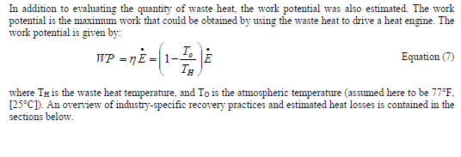

Figure 1: Work potential calculation

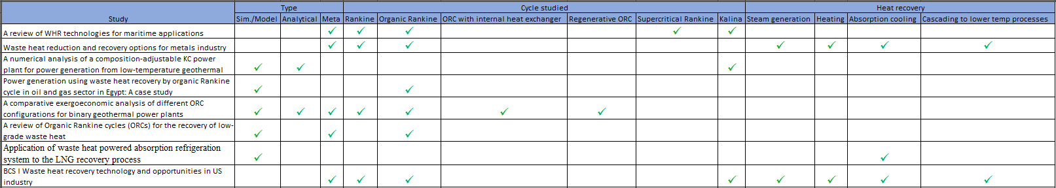

# Feasibility

## Cycle selection

There are many thermodynamic cycles that have been developed for the purpose of producing electrical power from heat. The majority of them make use of large temperature differentials and high heat quality as these cycles require the lowest level of technical complexity and upfront cost. There are also a number of cycles that have been developed for the utilization of lower heat source quality and those sources are the object of examination in this section.

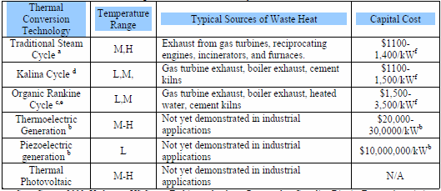

Figure 2: Ranking of energy generation cycles. SOURCE!?!

Of particular interest in this study are the Organic Rankine Cycle (ORC), so named for the hydro-carbons and refrigerants that are typical working fluids used in those cycles, and the Kalina cycle which is typically implemented with a water/ammonia mixture for a working fluid. The ratio of which is varied depending on the temperature of the heat source.

ORCs make use of hydrochlorofluorocarbons (HCFSs) fossil fuels such as propane and refrigerants such as R134a, R22, and R245fa. These working fluids make the ORC particularly well suited to low heat quality applications due to their high molecular weight and low phase transition temperatures. [2]

A single stage turbine is typically used for an ORC [2] which greatly reduces the technical complexity and size of the turbine, both of which are positive features for an automotive application where physical space is crucial.

The Kalina cycle is a modified form of the Rankine cycle and has a better operating efficiency in certain applications. Within the temperature range 200oC - 400oC, the Kalina cycle is 20% - 40% more efficient than a standard Rankine cycle. Some studies indicated that the Kalina cycle had better thermodynamic performance than the organic Rankine cycle as well. Because of the ammonia-water mixture used for a working fluid and the industry's long experience with both substances the Kalina cycle is also considered safe and environmentally friendly. This is not the case with some of the fossil fuels and refrigerants used in some organic Rankine cycles. [2]

Thermoelectric and Piezoelectric generation both show promise with their low technical complexity and long service life due to the lack of moving components. Unfortunately, both of those strategies promise very low efficiency and power yield for a small automotive application. They also require expensive materials for fabrication.

For the reasons outlined above, the organic Rankine cycle was selected for further study and for implementation in this project.

## Working fluid

There are several viable working fluids for the organic Rankine cycle. The usage of each depends on a number of factors. Foremost among those factors are the working temperatures and pressures of the desired system. The development of these parameters is discussed in greater detail in section 4.2.

## Heat exchange

According to Singh and Pedersen’s work, a heat balance for a typical maritime application might look like the following diagram.

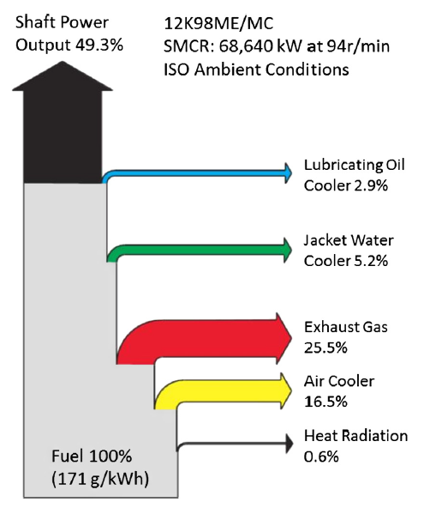

Figure 3: Heat balance diagram for MAN 12K98ME/MC marine diesel engine operating at 100 SMCR under ISO conditions [2]

“Engine cooling water temperatures of 80-90 oC are fairly standard for most engines.” [2] While exhaust gas appears to be the most lucrative source of waste heat energy, there are several complications which, though not as important for the Pederson and Singh study, would prevent it’s being as lucrative in an automotive application. Some of these factors are the increase in exhaust back pressure on the engine, the cooling of exhaust gases below the dew point of steam which could result in liquid water in the exhaust system causing corrosion, and reduced efficacy of reactions in the catalytic converter due to sub-optimal temperatures and high pressures caused by the heat harvesting system.

For waste heat streams with a temperature of 95 oC – 260 oC it was recommended that an ORC be used for power generation. It was also noted that the least efficient form of energy recovery from waste heat at this time is electrical generation. [3]

The Kalina Cycle (KC) is another variation on the RC that utilizes low temperature heat sources. The KC uses a variable composition working fluid mixture, typically water and ammonia to track with the heat sink temperature available. The efficiency of a KC can be increased due to a close temperature match with heat transfer fluids in the evaporator and condenser. “For instance, a KC system using an ammonia-water mixture as the working fluid to generate power from waste heat of a gas turbine achieved a thermal efficiency of 32.8%.” [4] “Some studies showed that a KC can achieve a better thermal efficiency than ORC systems.” [4] “In practice, the expansion ratio of the turbine for KCS-34 is relatively high and a multi-stage turbine is required.” [4] This may be the drawback of the KC that makes ORC somewhat more attractive for an automotive application due to the extreme space requirements though it might be marginally less efficient. The KC also requires a significant amount of control in order to adjust the mass-fraction of ammonia including density sensors and real-time monitoring of working fluid composition in some implementations making this cycle significantly more complicated to implement. KC is also generally used as a method of improving a conventional (steam) RC. Therefore, the system architecture tends to be similar. It also appears that the working temperatures are slightly higher than some refrigerant based ORCs. “When the ammonia mass fraction is 0.8, the bubble and dew temperatures are around 60.3 and 147.3 oC respectively.” [4]

The ORC is a promising cycle for recovery of energy from low heat sources. However, it has been shown that for certain working fluids, benzene or cyclohexane, the most suitable conditions were an expander inlet pressure of 4.1 MPa and temperature of 290 oC – 300oC. [5]

R134a appeared to be the most suitable for small scale solar applications, though R152a, R600a, R600 and R290 were promising though they required handling precautions due to their flammability. Isobutene also showed improved system performance when compared to R123 and R245fa. [5] Reading through the literature review in M.A. Khatita et al. did not show consensus on the best working fluid for ORC, however. With most fluids the use of a regenerative ORC instead of the basic cycle reduced the irreversibility of a solar ORC. Additionally, at the two temperature ranges studied fluids with higher molecular complexity resulted in more effective regenerative cycles with the exception of cyclo-hydrocarbons. [5] This was primarily due to higher turbine efficiency and increased mass flow rates.

“Unlike water, most organic fluids suffer chemical decomposition and deterioration at high temperatures and pressures.” [6] ORC systems showed efficiency gains with higher turbine inlet pressures, and efficiency losses for higher condenser outlet temperatures. This suggests that operating conditions, primarily temperature, could have a significant effect on the efficiency of a given system. [6]

# Preliminary results

## Working fluid

The most common working fluids used in ORC are R134a, R245fa, R22, isobutene, pentane, propane and PFCs. In the past, CFCs and HCFC were commonly used but are being phased out of current applications, and avoided for new applications due to environmental and safety concerns.

The working fluid used for the preliminary study was R245fa, a popular choice for similar applications with medium to low grade waste heat. The phase transition diagram is shown below. A table from the same source was used in the Python model used to produce the results in the following section.

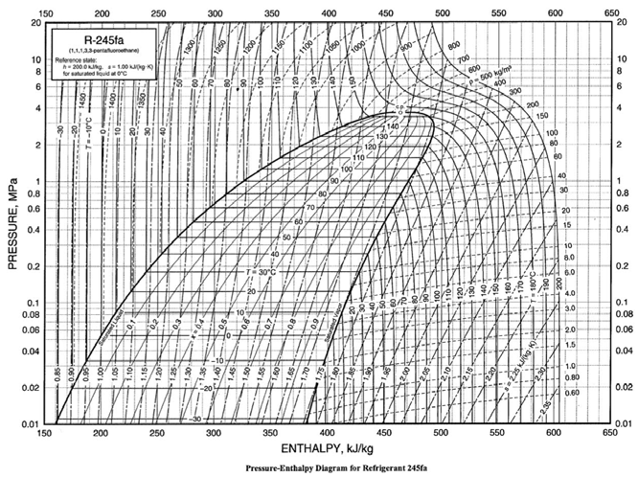

Figure 4: R245fa Pressure/Enthalpy diagram [7]

The proposed study will explore other common working fluids as one of the parameters in the ORC model.

## Working pressures and temperatures

A simple Rankine vapor power cycle was modelled like the diagram shown in Figure 5. The model was produced in Python as shown in Appendix C – Source Code.

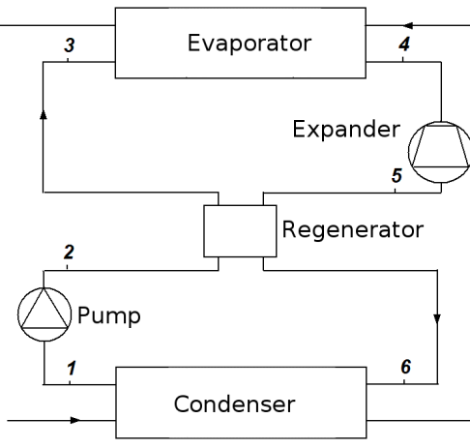

Figure 5: Typical Rankine cycle

The results from this model are shown in the following figures, which, if valid will inform a more nuanced model of a design space in which to start:

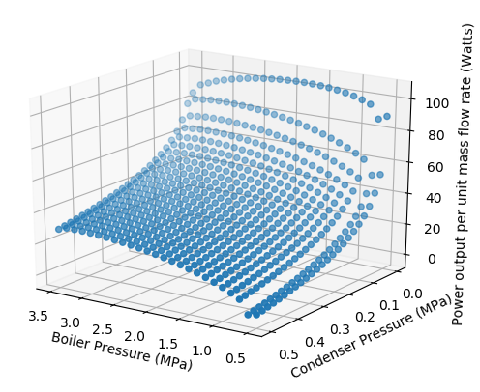 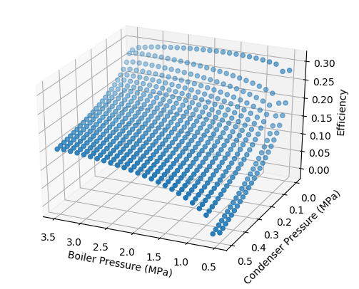

Figure 6: Power output per unit mass flow rate and efficiency by boiler and condenser working pressures

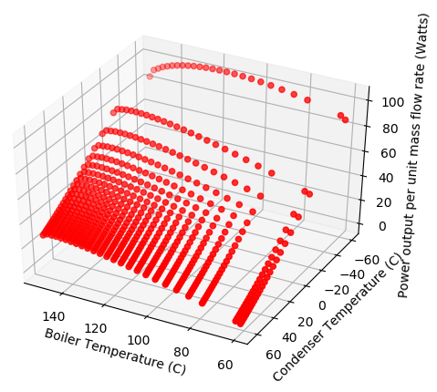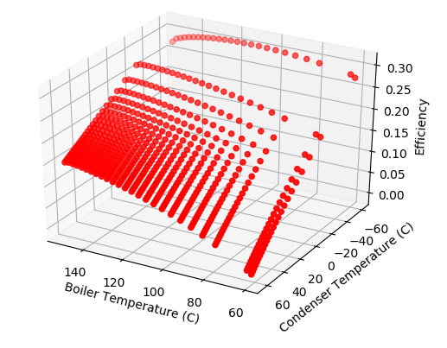

Figure 7: Power output per unit mass flow rate and efficiency by boiler and condenser working temperatures

## Increased energy efficiency

One must be able to justify the addition of any waste heat recovery system by several factors. The first is that the system must increase energy efficiency of the process onto which it is added by a quantity meeting or exceeding the energy cost to the system which includes it. In an automotive application the most obvious way an added system taxes the automobile is with increased mass which the system is now responsible for accelerating. Put another way, the WHR system must generate at least enough energy to accelerate its own mass; otherwise it does not contribute in a positive way to the energy balance of the vehicle. Another way in which the system must pay for itself, though not always a requirement for a consumer, is that the system should recover enough energy to offset its own manufacture.

# Experimental design

Some of the parameters of the system cannot be independent for each of the subsystems. The parameter that is necessarily shared by all subsystems is the working fluid and the mass flow rate of the working fluid.

## Boiler factors

In addition to the working pressure and temperature of the boiler, mass flow rates of the heat source, the working fluid from the automobile’s cooling system, and of the vapor power system can both be manipulated to increase the rate of heat transfer. The interaction surface area of the heat exchanger can also be manipulated.

## Turbine factors

The number of stages, and turbine blade size, shape, and angle can all be manipulated to affect the efficiency of the turbine. The type of cycle in this case, the organic Rankine cycle, also has a large effect on the efficiency of this component of the system.

## Condenser factors

In addition to the working pressure and temperature of the condenser, the mass flow rate of the vapor power system can be manipulated. The mass flow rate of the heat sink, the ambient air, is harder to manipulate. The interaction surface area of the heat exchanger can also be manipulated.

The condenser also represents a potential design challenge in an automotive application because the environment in which the system will be placed, the engine compartment, can be expected to have a highly variable temperature. It will also not be practically feasible to manipulate that temperature in any meaningful way.

## Pump factors

The pump working pressure can be manipulated, and it may be possible to drive the pump directly with mechanical energy from the turbine shaft rather than electrically which could represent some efficiency gains. This area is also of particular interest to GHSP as they design and manufacture pumps currently and can be considered experts in this area.

# Discussion

# Conclusion

# Appendix A – Acronyms

C – Celsius

CHP – Combined cooling heating and power

F – Fahrenheit

LNG – Liquefied natural gas

ORC – Organic Rankine cycle

RC – Rankine cycle

SCRC – Super-critical Rankine cycle

SRC – Steam Rankine cycle

WHR – Waste heat recovery

WHRS – Waste heat recovery system

# Appendix C – Source Code

import csv

import math

from mpl_toolkits.mplot3d import axes3d

import matplotlib.pyplot as plt

import numpy as np

def interpolate(x1,y1,x2,y2,x):

try:

y = ((y2-y1)/(x2-x1))*(x-x1) + y1

except TypeError:

y = y1

return(y)

def vlookup(rfile, index, search_col, result_col):

# The file is where the data is stored.

# index is the item to search rows for.

# search_col is the column in which the index should be searched for.

# result_col should be the column from which the result should be extracted.

index = float(index)

search_col = int(search_col)

result_col = int(result_col)

RDR = csv.reader(rfile, dialect = 'excel')

pos_diff = 1000

neg_diff = -1000

x1 = None

y1 = None

x2 = None

y2 = None

for row in RDR:

# Search for the rows just smaller and just larger than the search

# term. Calculate the difference between the x value in a given row

# and the search term. Keep the rows that result in the smallest

# positive difference and the smallest negative difference.

try:

diff = index - float(row[search_col])

except ValueError:

if row[search_col] == "Inf":

diff = math.inf

#print("Header?")

continue

if diff < pos_diff and diff > 0:

x1 = float(row[search_col])

y1 = float(row[result_col])

pos_diff = diff

elif diff > neg_diff and diff < 0:

x2 = float(row[search_col])

y2 = float(row[result_col])

neg_diff = diff

elif diff == 0:

x1 = float(row[search_col])

y1 = float(row[result_col])

x2 = None

y2 = None

return (x1, y1, x2, y2)

# Return the x,y pairs of the search column and result column just

# above and below the desired x value.

#----------Main----------#

fig = plt.figure()

fig1 = plt.figure()

fig2 = plt.figure()

fig3 = plt.figure()

ax = fig.add_subplot(111, projection='3d')

ax1 = fig1.add_subplot(111, projection='3d')

ax2 = fig2.add_subplot(111, projection='3d')

ax3 = fig3.add_subplot(111, projection='3d')

#b_press = np.arange(30,154.01,10)

#c_press = np.arange(0.00127,30, 1)

c_press = np.linspace(0.1225, 0.5, 25)

b_press = np.linspace(0.5,1,25)

X = []

X2 = []

Y = []

Y2 = []

Z = []

Z2 = []

for xs in c_press:

for ys in b_press:

boiler_pressure = ys

condenser_pressure = xs

#print("Boiler pressure: ", boiler_pressure,"\nCondenser pressure: ",condenser_pressure)

##boiler_pressure = 1

##condenser_pressure = 0.25

temp_col = 0 # Degrees Celsius

press_col = 1 # MPa

v_col = 3 # Specific volume of vapor m3/kg

hl_col = 4 # Enthalpy of saturated liquid kJ/kg

hv_col = 5 # Enthalpy of saturated vapor kJ/kg

sl_col = 6 # Entropy of saturated liquid kJ/(kgK)

sv_col = 7 # Entropy of saturated vapor kJ/(kgK)

R245fa_db = 'R245fa Saturated properties temperature table.csv'

db_path = 'H:\\WIP\\12343 - Research & Development\\Issue #251 - Rankine cycle research\\Additional references'

# Fix states with specified pressures

p1 = boiler_pressure

p4 = boiler_pressure

file = open("%s/%s" %(db_path, R245fa_db), mode = 'r', newline='')

x1, y1, x2, y2 = vlookup(file, p1, press_col, temp_col)

boiler_temp = interpolate(x1, y1, x2, y2, p1)

file.close()

p2 = condenser_pressure

p3 = condenser_pressure

file = open("%s/%s" %(db_path, R245fa_db), mode = 'r', newline='')

x1, y1, x2, y2 = vlookup(file, p2, press_col, temp_col)

condenser_temp = interpolate(x1, y1, x2, y2, p2)

file.close()

file = open("%s/%s" %(db_path, R245fa_db), mode = 'r', newline='')

x1, y1, x2, y2 = vlookup(file, p1, press_col, hv_col)

h1 = interpolate(x1, y1, x2, y2, p1)

#print("h1 = ", h1)

file.close()

file = open("%s/%s" %(db_path, R245fa_db), mode = 'r', newline='')

x1, y1, x2, y2 = vlookup(file, p1, press_col, sv_col)

s1 = interpolate(x1, y1, x2, y2, p1)

s2 = s1

#print("s1 = ", s1,"\ns2 = ", s2)

file.close()

# Calculate the quality of state 2

# First find the liquid and vapor entropy at the condenser pressure

file = open("%s/%s" %(db_path, R245fa_db), mode = 'r', newline='')

x1, y1, x2, y2 = vlookup(file, p2, press_col, sl_col)

s2L = interpolate(x1, y1, x2, y2, p2)

file.close()

file = open("%s/%s" %(db_path, R245fa_db), mode = 'r', newline='')

x1, y1, x2, y2 = vlookup(file, p2, press_col, sv_col)

s2v = interpolate(x1, y1, x2, y2, p2)

file.close()

#print("sL = ",s2L,"\nsv = ", s2v)

try:

qual_2 = (s2 - s2L)/(s2v - s2L)

except ZeroDivisionError:

qual_2 = 0

except RuntimeWarning:

qual_2 = 0

#print("x2 = ", x2)

# Note that evaporating enthalpy is equal to the difference between the enthalpy

# of a saturated vapor and the enthalpy of a saturated liquid at a given

# temperature or pressure.

file = open("%s/%s" %(db_path, R245fa_db), mode = 'r', newline='')

x1, y1, x2, y2 = vlookup(file, p2, press_col, hl_col)

h2L = interpolate(x1, y1, x2, y2, p2)

#print("h2L = ", h2L)

file.close()

file = open("%s/%s" %(db_path, R245fa_db), mode = 'r', newline='')

x1, y1, x2, y2 = vlookup(file, p2, press_col, hv_col)

h2v = interpolate(x1, y1, x2, y2, p2)

#print("h2v = ", h2v)

hLv = h2v - h2L

#print("hLv = ", hLv)

file.close()

h2 = h2L + (qual_2*hLv)

#print("h2 = ", h2)

file = open("%s/%s" %(db_path, R245fa_db), mode = 'r', newline='')

x1, y1, x2, y2 = vlookup(file, p2, press_col, hl_col)

h3 = interpolate(x1, y1, x2, y2, p2)

file.close()

#print("h3 = ", h3)

file = open("%s/%s" %(db_path, R245fa_db), mode = 'r', newline='')

x1, y1, x2, y2 = vlookup(file, p2, press_col, v_col)

v3 = interpolate(x1, y1, x2, y2, p2)

file.close()

#print("v3 = ", v3)

h4 = h3 + v3*(p4-p3)

#print("h4 = ", h4)

W_m = h1-h2-h4+h3 # Watts of power per kg/s of mass flow rate

#print("Watts per kg/s of mass flow rate = ", W_m)

efficiency = ((h1-h2) - (h4-h3))/(h1 - h4)

X.append(boiler_pressure)

X2.append(boiler_temp)

Y.append(condenser_pressure)

Y2.append(condenser_temp)

Z.append(W_m)

Z2.append(efficiency)

ax.set_xlabel("Boiler Pressure (MPa)")

ax.set_ylabel("Condenser Pressure (MPa)")

ax.set_zlabel("Power output per unit mass flow rate (Watts)")

ax.scatter(X, Y, Z)

ax1.set_xlabel("Boiler Pressure (MPa)")

ax1.set_ylabel("Condenser Pressure (MPa)")

ax1.set_zlabel("Efficiency")

ax1.scatter(X, Y, Z2)

ax2.set_xlabel("Boiler Temperature (C)")

ax2.set_ylabel("Condenser Temperature (C)")

ax2.set_zlabel("Power output per unit mass flow rate (Watts)")

ax2.scatter(X2, Y2, Z, color='r')

ax3.set_xlabel("Boiler Temperature (C)")

ax3.set_ylabel("Condenser Temperature (C)")

ax3.set_zlabel("Efficiency")

ax3.scatter(X2, Y2, Z2, color='r')

plt.show()

# References

|  |  |
| --- | --- |
| [1] | BCS, Incorporated, "Waste Heat Recovery: Technology and Opportunities in U.S. Industry," *U.S. Department of Energy Industrial Technologies Program,* p. 112, 2008. |
| [2] | E. P. Dig Vijay Singh, "A review of waste heat recovery technologies for maritime applications," *Energy Conversion and Management,* no. 111, pp. 315-328, 2016. |
| [3] | C. B. Arvind Thekdi, "Waste Heat Reduction and Recovery Options for Metals Industry," *Energy Technology. John Wiley & Sons, Inc.,* pp. 17-24, 2011. |
| [4] | Z. Y. Enhua Wang, "A numerical analysis of a composition-adjustable Kalina cycle power plant for power generation from low-temperature geothermal sources," *Applied Energy,* vol. 180, pp. 834-848, 2016. |
| [5] | T. S. A. F. H. A. I. M. I. Mohammed A. Khatita, "Power generation using waste heat recovery by organic Rankine cycle in oil and gas sector in Egypt: A case study," *Energy,* vol. 64, pp. 462-472, 2013. |
| [6] | T. C. Hung, T. Shai and S. K. Wang, "A Review of Organic Rankine Cycles (ORCs) for the Recovery of Low-Grade Waste Heat," *Energy,* vol. 22, no. 7, pp. 661-667, 1997. |
| [7] | American Society of Heating, Refrigerating and Air-Conditioning Engineers, Inc., "Chapter 30 - Thermophysical Properties of Refrigerants," in *2009 ASHRAE Handbook*, Atlanta, https://app.knovel.com/hotlink/toc/id:kpASHRAE37/ashrae-handbook-fundamentals/ashrae-handbook-fundamentals, 2009, p. 75. |
| [8] | BCS, Incorporated, "Waste Heat Recovery: - Technology and Opportunities in U.S. Industry -," 2008. |
| [9] | 15 December 2017. [Online]. Available: https://en.wikipedia.org/wiki/Carnot_cycle. |
| [10] | 28 December 2017. [Online]. Available: https://hellafunctional.com/?p=629. |
| [11] | J. P. Holman, "Heat Transfer," in *Heat Transfer*, New York, McGraw-Hill, 2010, p. 713. |